4CS015
FUNDAMENTALS OF COMPUTING
PORTFOLIO
Part-2

Name: -Rohit Sahani
Student Id: -NP02CS4A250027

Workshop tasks:
Arithmetic Logic Unit
Load the LogSim Arithmetic Logic Unit Circuit alu.cct from inside the logsim application (You'll find it in the logsim folder) or the ALU for CircuitVerse. ALU.cv. It should look like these:
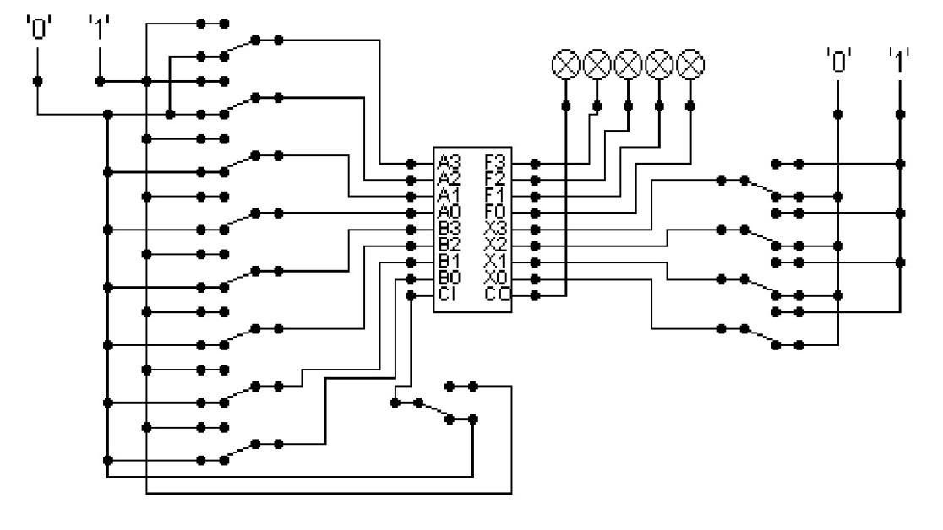

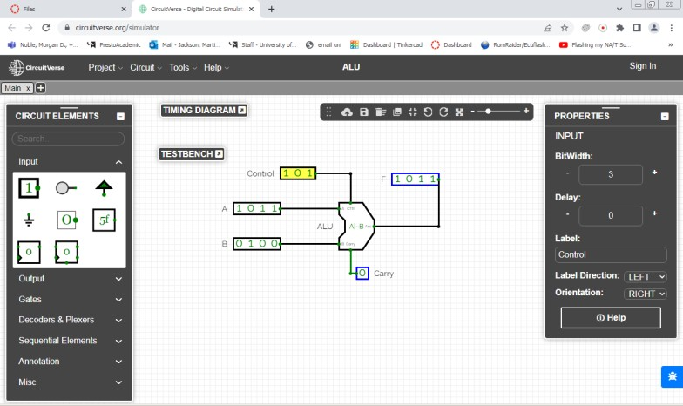

The circuit behaves like a simple arithmetic logic unit. The inputs A0-A3 represent a 4-bit binary number. Inputs B0-B3 represent another binary number. A0 and B0 are the least significant bits respectively. The following table details the functions supported by the chip. Logsim control settings

Function | AND | OR | XOR | NAND | NOR | NOT A | ADD | SUBTRACT
X3 – X0 | 0000 | 0001 | 0010 | 0011 | 0100 | 0101 | 1010 | 1011

CircuitVerse control settings
Opcode | Operation
0 0 0 | A & B AND
0 0 1 | A | B OR
0 1 0 | A + B ADD
0 1 1 | No spec
1 0 0 | A & ~B A AND notB
1 0 1 | A | ~B A OR notB
1 1 0 | A – B SUBTRACT
1 1 1 | SLT A<B (Set Less Than): If A is less than B, output is 1 else output is 0.

- Use A= 11 B=4, complete the following table in binary (8 marks):

FUNCTION | OUTPUT
AND | 00000
OR | 01111
ADD | 01111
SUBTRACT | 00111

AND operation: -

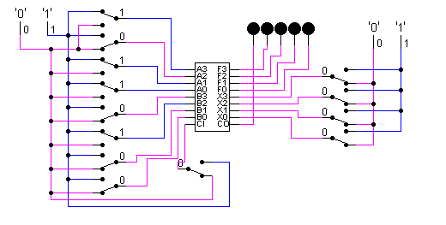
Output: -00000

OR operation: -

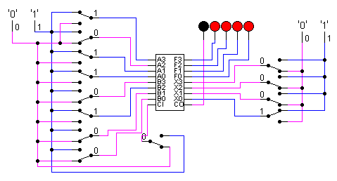
Output: -01111

ADD operation: -

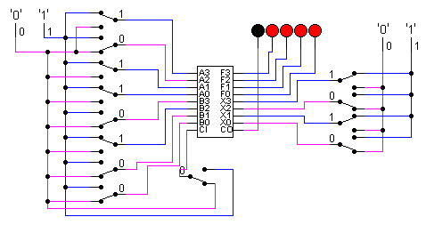

Output: -01111

SUBTRACT operation: -

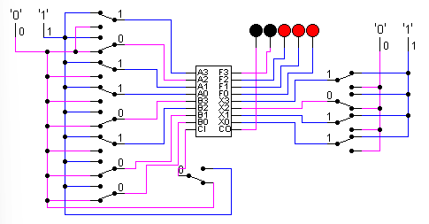

OUTPUT: -00111

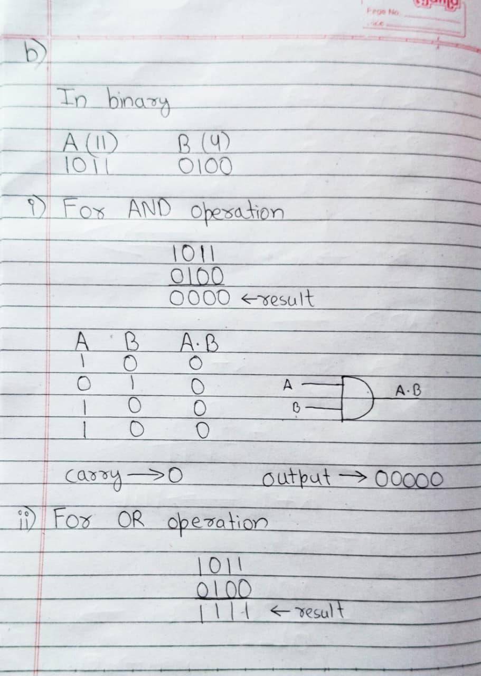
- Use the logical operations (bitwise). Manually prove each operation has returned the correct result (8 marks), show your working out for all off the above answers.
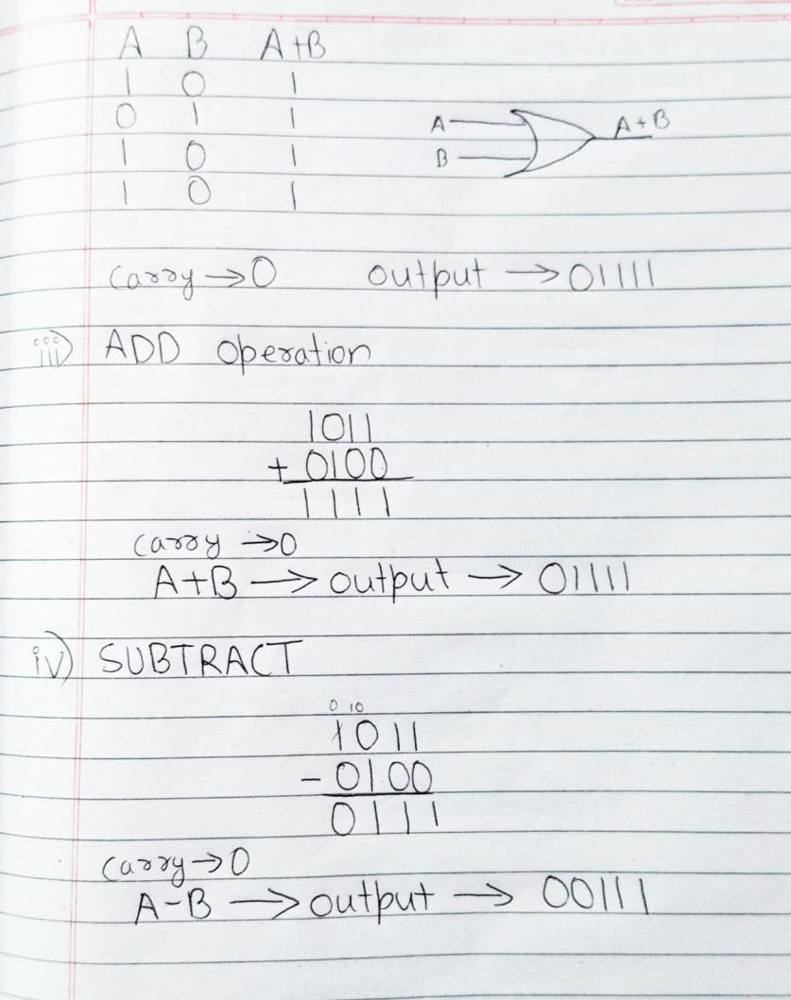

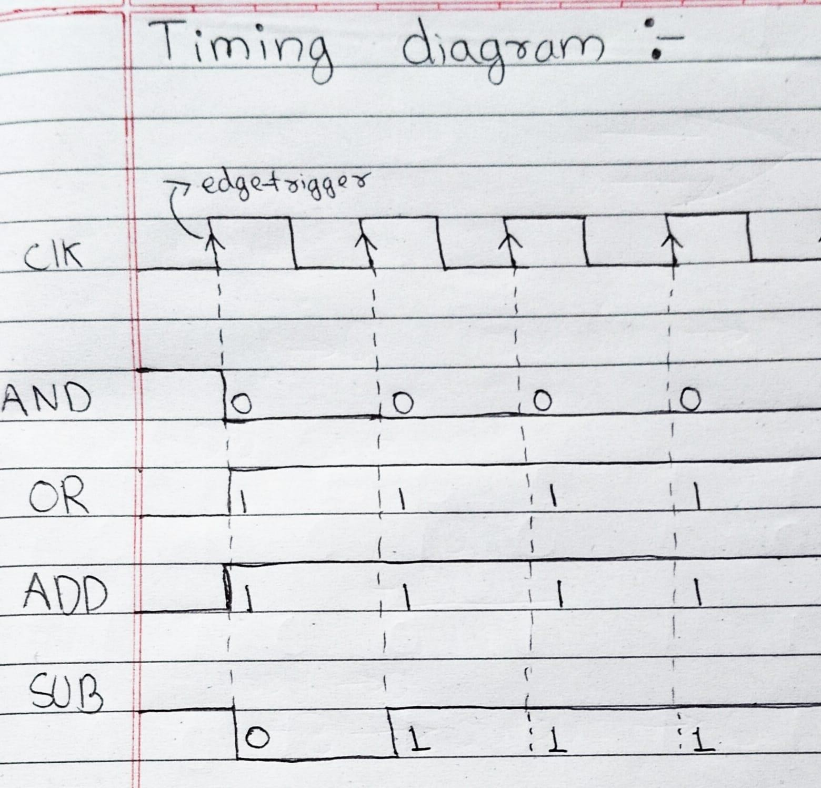

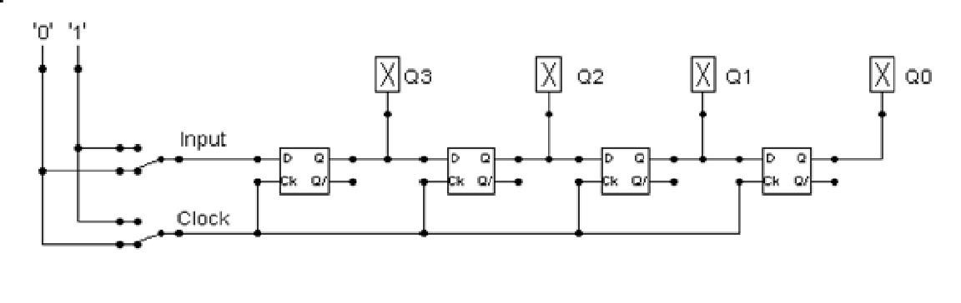
- Build the circuit above (10 marks).
Answer: submitted as .cct file
- and complete the following timing diagram by filling in the table spaces with ‘1’ or ‘0’. (16 marks)
Remember to disable preset/clear for the d-type in properties (logsim).
Use the DFLIPFLOP in CircuitVerse to construct the circuit.
You may need to clock 0-1 a few times when the circuit is running to get the output required.
Note where Q3-Q0 are on the table and on the logic circuit.

Input | 1 | 1 | 0 | 0 | 1 | 1 | 1 | 1 | 0
Clock | 0 | 1 | 0 | 1 | 0 | 1 | 0 | 1 | 0
Q3 | 1 | 1 | 1 | 0 | 0 | 1 | 1 | 1 | 1
Q2 | 1 | 1 | 1 | 1 | 1 | 0 | 0 | 1 | 1
Q1 | 1 | 1 | 1 | 1 | 1 | 1 | 1 | 0 | 0
Q0 | 1 | 1 | 1 | 1 | 1 | 1 | 1 | 1 | 1

- Next, describe what the circuit does. (8 marks)
= The circuit is a 4-bit shift register that operates using a clock signal. It stores and shifts data in a controlled, step-by-step manner.
The circuit works synchronously, meaning the outputs change only when the clock is high. When the clock is low, the outputs Q3 to Q0 remain unchanged, which shows that the circuit uses clocked storage elements (flipflops).
On each active clock pulse:
  - The input bit is loaded into Q3
  - The existing data shifts one position to the right:
o Q3 moves to Q2
o Q2 moves to Q1
o Q1 moves to Q0
This process allows the circuit to store previous input values. Each output represents the input from an earlier clock cycle:
  - Q3 holds the most recent input
  - Q2 holds the input delayed by one clock pulse
  - Q1 holds the input delayed by two clock pulses
  - Q0 holds the input delayed by three clock pulses
From the table, Q0 always remains at logic 1. This indicates that the circuit has no reset or clear input, so once a logic 1 reaches Q0, it remains there.
Final summary
The circuit functions as a 4-bit serial-in, parallel-out shift register, used for temporary data storage and time-delayed output of digital signals.

Combining everything we have covered so far (lectures 3-6).
Look at the circuits below: -

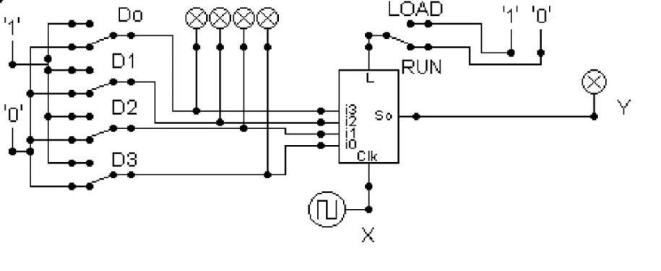
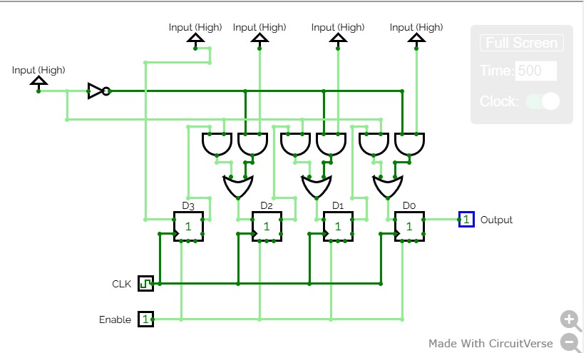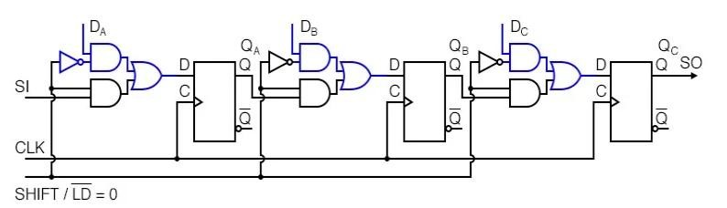
Logsim

Circuit verse
-

Dflipflops used with load circuit
3
-
bit input
first input is
(
serial
-
in not used
.
)
The circuit has another

input

that

allows the selection between
load input

and
shift register

mode. (
ref: circuitverse diagram).

Above is
a 3
-
stage shift register
. A stage consists of a type

D

p
Fli
-
p
Flo

for storage, and
an AND
-
OR selector to determine whether data will load in parallel, or shift stored data to the
right. These elements will be replicated for the number of stages required. We show here only

three stages
.
SI
has been provided to allow us to cascade shift registers.

- Describe what these circuits do, please provide details by clock pulse and the changing of the shift/load input (all the circuits do same thing, except the logsim version has no serial in). (10 marks)

= The circuits presented are 3-stage universal shift registers, designed using D-type flip-flops and AND-OR selector logic gates to perform two distinct functions: parallel data loading and serial data shifting to the right.
The operation is determined by the logic level of the control input, labeled SHIFT/LD (or LOAD/RUN in the top diagram), and synchronized by a clock pulse (CLK).

Parallel Load Mode (SHIFT/LD = 1)
When the SHIFT/LD input is set to high (logic 1):
  - The circuit is configured for parallel data loading.
  - The AND gates connected to the parallel input lines (D0, D1, D2, and for the top circuit, also the 'Load' and 'Run' inputs) are enabled.
  - The AND gates that facilitate shifting are simultaneously disabled.
  - On the very next active clock edge (which is negative-edge triggered for the bottom circuit diagram), the data present at the D0, D1, and D2 inputs is loaded simultaneously into the corresponding three D flip-flops.
  - The outputs Q0, Q1, and Q2 instantly reflect the state of their respective parallel inputs (D0, D1, D2). The serial input (SI) line is ignored in this mode.

Shift Register Mode (SHIFT/LD = 0)
When the SHIFT/LD input is set to low (logic 0):
  - The circuit is configured for right-shifting the stored data.
  - The AND gates for parallel loading are disabled, while the AND gates that pass data from one flip-flop's output to the next input are enabled.
  - On each successive active clock edge:
    - The data bit present at the Serial Input (SI) line is loaded into the first flip-flop (Q2's position).
    - The data stored in the second flip-flop (Q1) is shifted into the first flip-flop (Q2).
    - The data stored in the third flip-flop (Q0) is shifted into the second flip-flop (Q1).
    - The data bit that was previously in the last flip-flop (Q0) is moved out to the Serial Output (SO) line.
4. This process allows the entire 3-bit word to be shifted out serially, one bit per clock pulse.
Answer:
The circuits are 3-bit universal shift registers that either perform parallel loading of a 3-bit data word when the SHIFT/LD control input is high, or right shift the entire stored word by one position with each clock pulse when the control input is low.

- Next, design a circuit that takes 4 inputs that takes the Clock X and the
Output Y and decodes Y into 4 output indicators so that they match D0 – D3. Insert the GIF output of your design in the space below. Highest marks will go to those who design the circuit such that it AUTOMATICALLY stops (not pauses) when the input to the circuit matches the output to the circuit. Screenshot your circuit and upload your logsim/circuitVerse file. Describe how your circuit works? (40 marks)

OUTPUT GIF: -

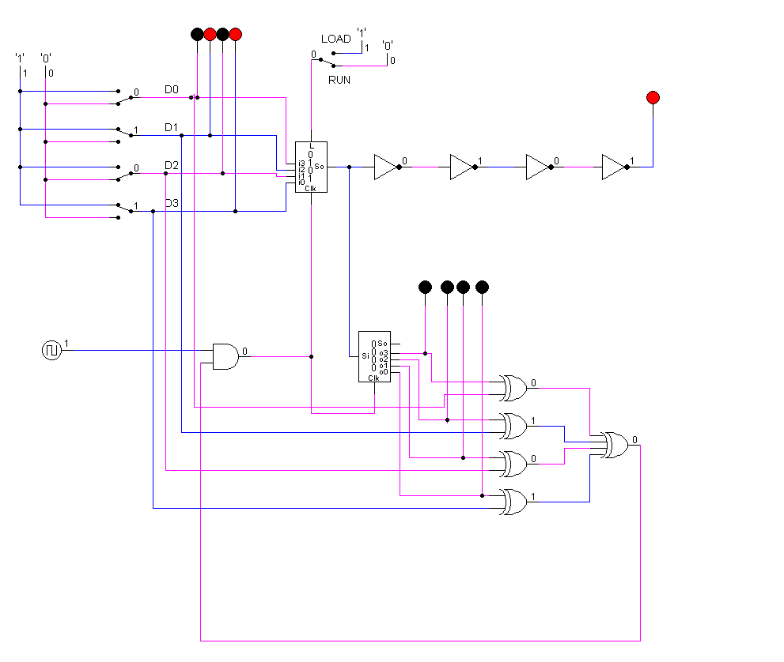

Detailed Circuit Analysis and Design Description

1. Functional Overview
The circuit is designed as a 4-Bit Linear Feedback Shift Register (LFSR). It features a dual-mode operation that allows for parallel data loading and serial data processing. The primary goal of the design is to take a specific 4-bit input "seed," cycle it through a sequence using feedback logic, and automatically terminate the operation when the internal state matches the initial input.

2. Hardware Architecture and Logic Components
- Initial Data Entry (D0 – D3): Four toggle switches allow the user to define the starting binary word. This acts as the reference point for the entire operation.
- Mode Control (LOAD/RUN): A manual switch controls the register's behavior.
  - In LOAD mode, the register accepts the 4 bits from the D switches.
  - In RUN mode, the register begins shifting bits on every clock pulse.
- The Shift Register Core: This integrated unit stores the 4 bits of data. With every "tick" of the clock, it moves bits from one stage to the next (from left to right).
- XOR Feedback Network: A series of XOR gates are connected to specific "taps" on the register outputs. These gates perform logic operations on the current bits to calculate a new bit, which is then fed back into the serial input. This creates a continuous, repeating loop of data.
- Inverter Output Chain: The serial output Y is routed through four NOT gates. This stabilizes the signal and ensures the red LED indicator displays the correct logic level without interfering with the internal timing.

3. The Automatic Stop Mechanism
To earn the highest marks, the circuit includes a Digital Comparator that acts as an automated "kill switch" for the clock.
- Bit-by-Bit Comparison: The circuit uses XNOR gates to compare the 4 input switches (D0–D3) against the 4 current outputs of the register. An XNOR gate is used because it only produces a 'High' signal when both inputs are identical.
- The Match Trigger: The outputs of these four XNOR gates are connected to a 4-input AND gate. This gate only turns "ON" when all four bits match perfectly.
- Automatic Halt: This match signal is connected to a "Clock Inhibit" gate. The moment a match is detected, the logic forces the clock signal to stay at 0. This effectively stops the circuit, freezing the indicators so the user can see that the output matches the input.

4. Summary of Operation
In short, the user "seeds" the circuit with a bit pattern and hits RUN. The circuit shifts the bits and calculates new ones using the XOR feedback. Simultaneously, the comparator logic "watches" the register. As soon as the register shifts back to a position that matches the original D switches, the comparator cuts the clock signal, stopping the circuit automatically. This demonstrates a complete closed-loop control system.

